Feasibility Analysis

**Description about the application:**

This application incorporates a system of file sharing in which the creator of a file is, by default, its owner. The owner can regulate the public accessibility of the file or folder.Files will be stored in Microsoft Azure storage services.The owner may also set an access level for regulating permissions.The storage solutions provide users and enterprises with various capabilities to share the data.This app lets the user protect and share your files people based on our state of the art Network Lock and Geo-Lock.This app does not store the data more than 3 days.

There are 4 types of locks by which the user can choose according to his requirements.

* Geo-Lock
* Network Lock
* Password
* None
* No login required .
* User data is stored in the database.
* All the list of keys are stored in local area memory.
* User can add files which he wants to share with others.
* Any no. of users can access file with valid access key and access criteria(Location,Network).
* A list of all files that are shared by other are displayed with the name of user

and date. User can select all files or a single file at once to copy files in his

local memory area.

**Survey:**

The following is the pie chart of the responses for the feasibility of our “one to many ” file sharing application.

Do you know a secured file sharing application which needs no login?

Do you know a secured file sharing application which can be done with multiple users at a time?

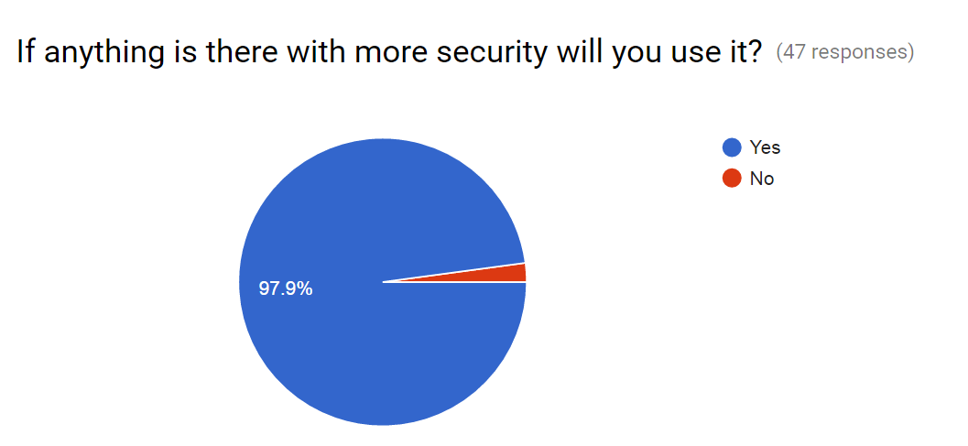

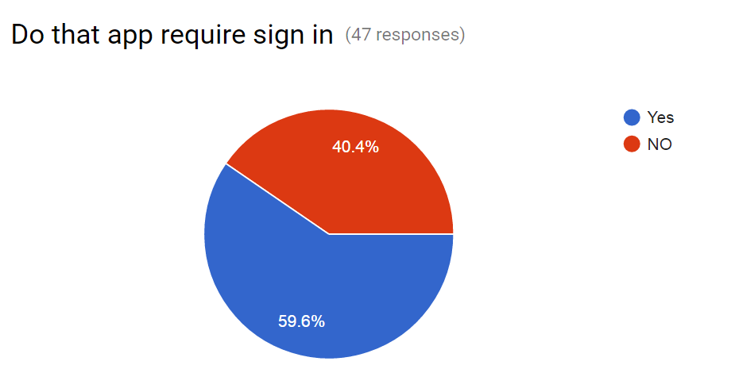

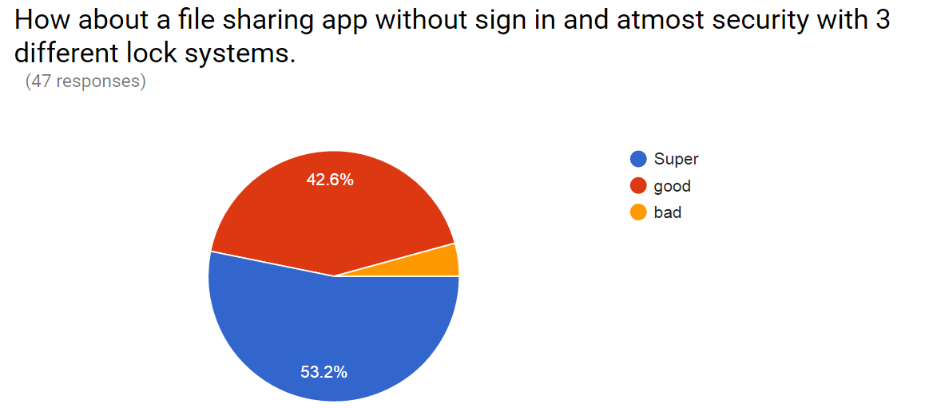

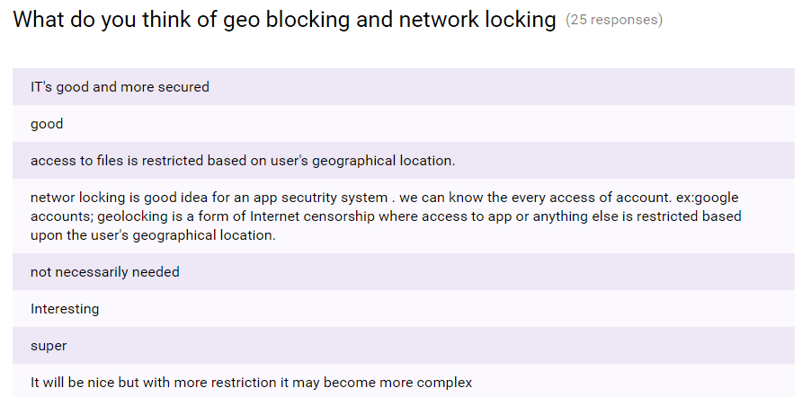

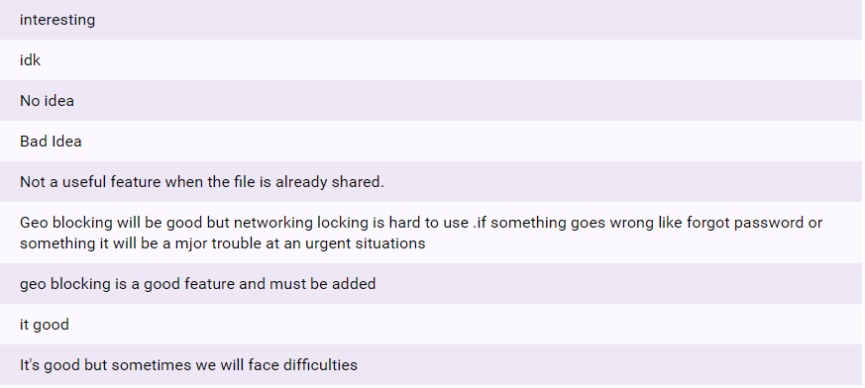

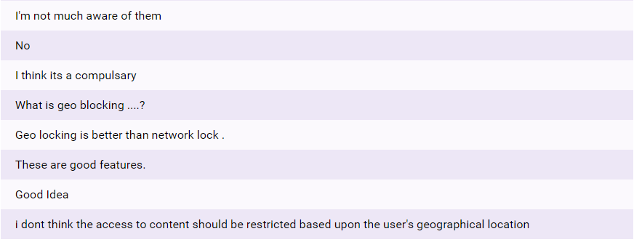

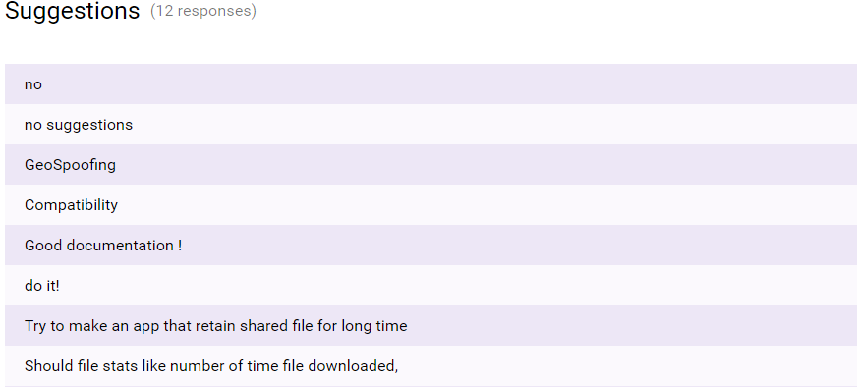

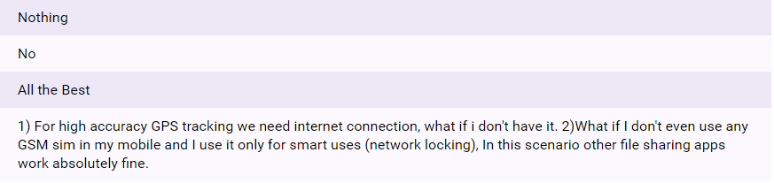

The above are the suggestions for “One to many” file sharing application. The study also resulted that the proposed system can contribute organisational objectives and can be done with in the present technology and budget.

**Some of the questions for people in Organisation which helps in the study of the system feasibility are as follows:**

**What are current process problems?**

Even though there are many file sharing but most of them are only “one to one” sharing. By chance if there is any “one to many” it requires user’s information (email id or user name etc) for accessing. So, here the problem arises when the user doesn’t want to share his personal information.

**How will the proposed system help?**

To overcome the above problem, we came up with a new idea of no sign is required. By this, there is no need of user/client’s information.

**Is new technology needed? What skills?**

Here there is need of GEO lock and Network lock. GPS is required for Geo lock to track the user’s location. In case of Network lock, it requires SSID of that particular network.

**Recommendation:**

From above all reviews it shows that the application is feasible. And also recommendable.